Junior Cycle Booklist | Publisher
English: Kingdom (1,2,3) 2nd Ed. Book & portfolio | educate.ie
Trash
Of Mice & Men | educate.ie
Merchant of Venice 2nd Ed. | educate.ie
English: Private Peaceful | Harper Collins
Maths: Active Maths 1, 2, 3 | Folens
Irish: Turas 1, 2, 3 (2nd Ed.) pack | educate.ie
Cúpla
French: En Avant! (class set) | EDCO
French: Allons-y 1 & 2 (2nd Edition) PLUS Portfolio | educate.ie
History: Artefact 2nd Ed. | Educate.ie
Geography: Down to Earth | Mentor
HE: Skills for Life | Folens
Exploring Science Textbook & workbook | EDCO
Music Maker | Gill Ed.
Graphic Solutions workbook | DCG Solutions
Art: Artventure Textbook & sketchpad | educate.ie
Wood Technology - Theory & practice 1st ed. | Peter Cusack & R. Foudy
Engineering
Business: Network 2nd Edition Book & workbook | educate.ie
CSPE: Make a difference | Folens
SPHE: Health & Wellbeing 1,2,3 | Edco
Religion: Enspire 1 | Educate.ie
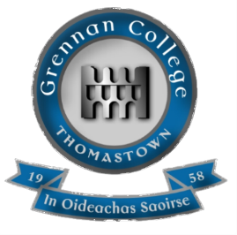
Grennan College
Junior Cycle Booklist 2024-25

